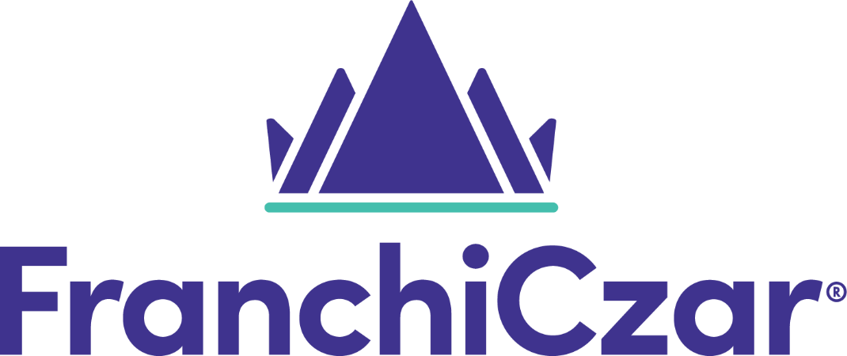

Automation User Guide

Updated July 26, 2021

Table of Contents
Automations: The Basics 4
What are Automations? 4
Why Should I use Automations? 4
Getting Started 4
Email Templates 6
Creating an Email Template 7
Step 1: Name Template 7
Step 2: Subject Heading 8
Step 3: Email Content 8
Node and User Fields 10
Nodes 10
FranchiCzar OS fields 10
Users 11
Workflows 12
Triggers 14
Conditions 14
Actions 16
Send an email 17
Send a text message 18
Update a field 20
Assign the lead to a user 21
Creating a Workflow 22
Example 1: The New Lead 22
Example 1: Completed Workflow 26
Example 2: The Tour Follow-Up 28
Blueprints 34
Frequently Asked Questions (FAQs) 35
Why are email templates under "Settings" and not "Automation”? 35
What if I use a template and have set the user as “the assigned user” but no user is assigned? 35
I have multiple conditions for trigger. How does FranchiCzar OS know what to check first? 35
My automations aren’t working for new leads. What’s happening? 35
What is a “parent” and why do I see it so much in automations? 36
Appendix A 37
Version History Table 37

Automations: The Basics

What are Automations?
Generally, automations are a set of triggers and actions that occur when an event takes place.

Automations happen around us every day whether we recognize them or not. The confirmation code sent to your phone, the spam filter in your inbox, your phone connecting to Wi-Fi automatically – all of these occur because an automation was set to do these things.

For FranchiCzar OS, automations are a Customer Relationship Management (CRM) tool that allows you to communicate with and update leads automatically. You won't have to worry about manually sending each new lead an email or text to remind them of their tour. FCOS' automations can do that for you!

Why Should I use Automations?
Decreasing the manual processes associated with new leads and follow-ups will afford you more time, allow you to reach out to leads when they are at their warmest, provide the resources to contact multiple leads per day, and cut down on leads who are not being contacted due to manual errors.

Overall, your lead follow-up and conversion processes will be more efficient with the use of automations.

Getting Started
FranchiCzar OS uses multiple features to automate processes. For example, a workflow for new leads may use Email Template A, while another may use Email Template B for following up after a tour.

FranchiCzar OS automations currently consist of two major components:

- Email templates
- Workflows

You can find these features by logging into FranchiCzar OS and looking at the left-hand navigation menu.

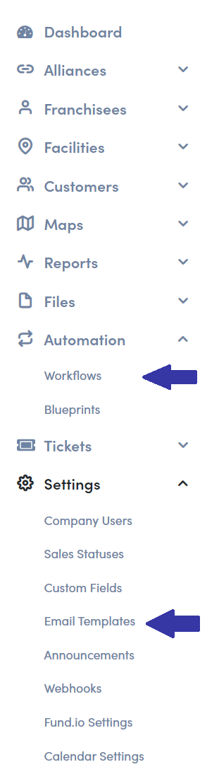

Email Templates
When you select Email Templates you are sent to a page with a list of available templates.
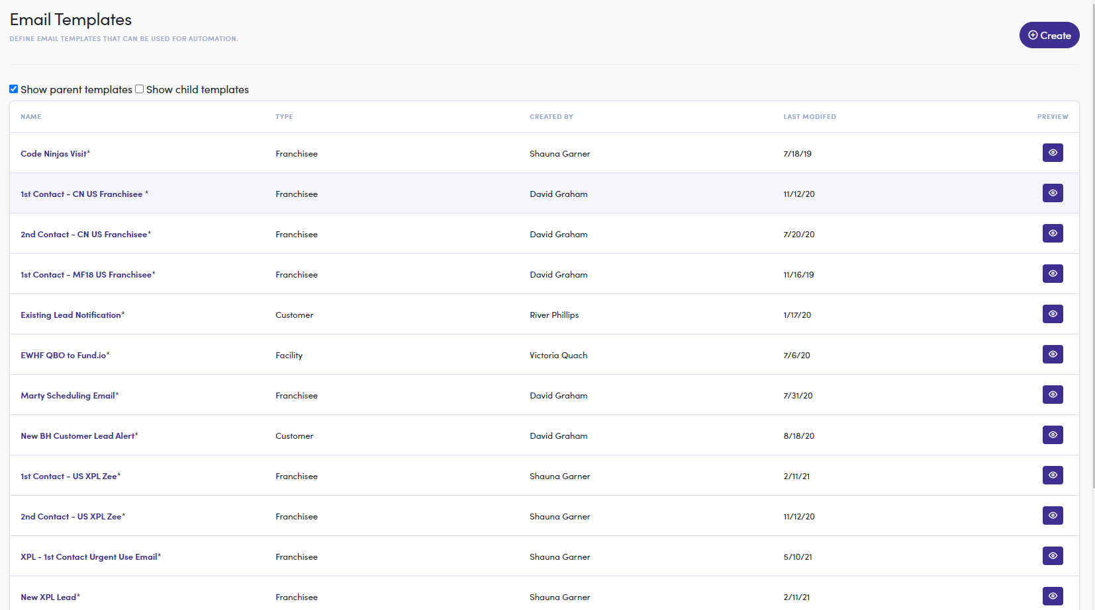

The list shows some details about the template:
- Name: What the template is called
- Type: Who you can use the template for
- Created by: Who the creator of the template is
- Last Modified: Date in which the template was last edited

The list of templates can be filtered by “Show parent templates.” Parent templates are made by people employed by the parent node. For example, the “parent” to a franchisee is a franchisor. The “parent” to a facility employee is the franchisee. If you would like to see only your center’s or franchisee’s templates, uncheck this option. Keep this option checked if you would like to see templates made by parent nodes.

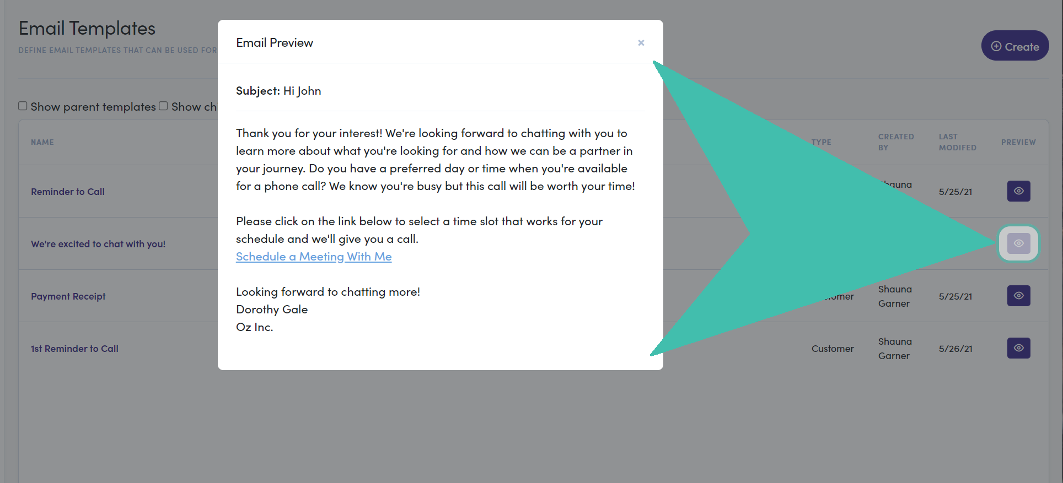
If you want to see what a template will look like to leads or customers, you can click the “Preview” eye icon on the right.

Creating an Email Template
To get started with your template, click the Create button (top-right) on the Email Templates page. You will be sent to a page to draft your email.
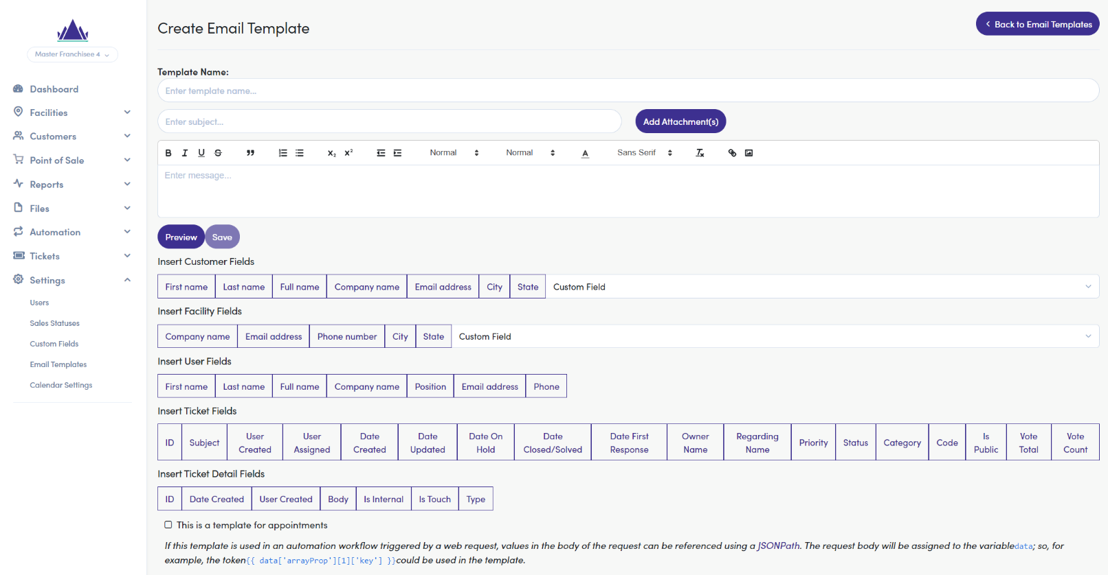

Step 1: Name Template
First, name your template.

Think of good keywords to identify what your template is. Be sure to keep the name unique and easy to find. For this example, we’ll call the template: “New Lead – Initial Email.”


The name of your template is completely internal and will not be shared with the customer.

Step 2: Subject Heading
Second, give your template an eye-catching subject.

If you’re sending an initial email to a lead, you want something that will stick. Simply putting “Thank you for your information” might not be convincing enough to open and read the email. Calls to action are a great place to start. For this example, our subject will be “We’re excited to chat with you!”
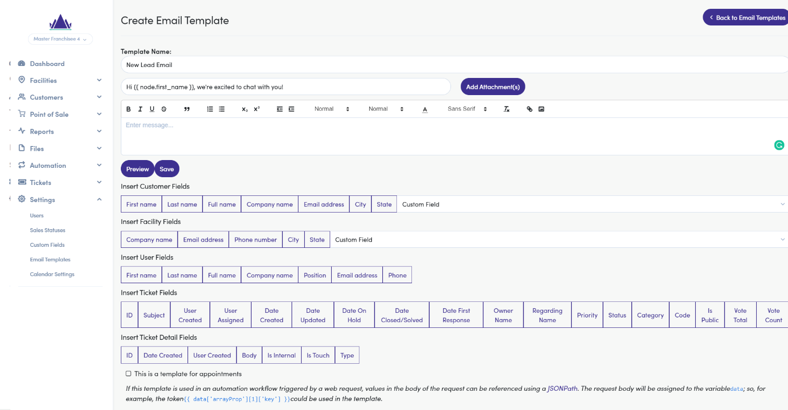

Step 3: Email Content
Third, populate the email’s body.

Here is a sample email:

Hi {{ node.first_name }},

Thank you for your interest! We're looking forward to chatting with you to learn more about what you're looking for and how we can be a partner in your journey. Do you have a preferred day or time when you're available for a phone call? We know you're busy, but this call will be worth your time!

Please click on the link below to select a time slot that works for your schedule, and we'll give you a call.
Schedule a Meeting With Me

Looking forward to chatting more!
{{ user.full_name }}
{{ user.company.company_name }}
{{ user.phone1 }}
{{ user.email_address }}

You might notice there are bracketed words like “{{ node.first_name }}” and “{{ user.phone1 }}”. These represent node entries and the user who is generating the email (see following section “Node and User Fields”).

Let’s dissect this message to better understand what these are and the power of automations.
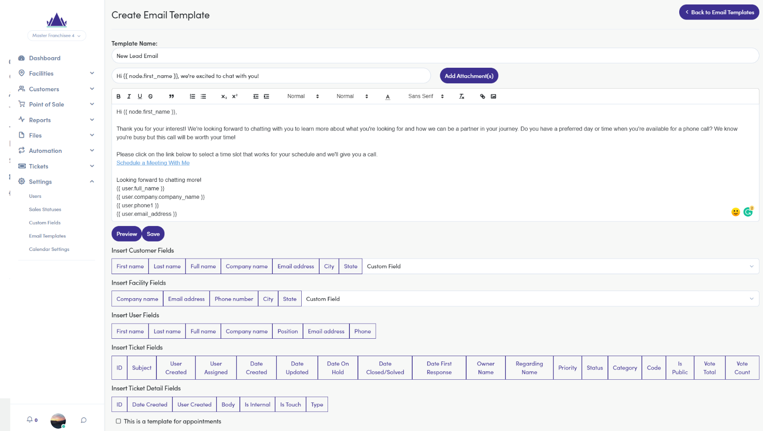

Node and User Fields

Nodes
When addressing the lead, we want to use their name to make it personalized. But how do we know what to call them in the email? That is where node and user fields come into play.

A node is a record containing information within FCOS. A node can represent a lead or customer, and all pertinent information will be contained with that node or record. You can think of a node as the person who submitted the lead form on your franchise webpage.
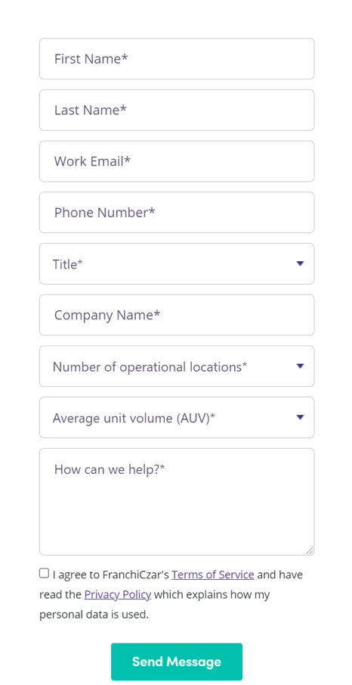

FranchiCzar OS takes the data entered for “First Name”, “Last Name”, etc. on the form and lets you use this data within templates.

FranchiCzar OS fields
Here is a breakdown of how the lead form integrates with FranchiCzar OS:

Lead form fields | = | FranchiCzar OS fields | = | Syntax
First Name | = | Node First name | = | {{ node.first_name }}
Last Name | = | Node Last name | = | {{ node.last_name }}
Email | = | Node Email address | = | {{ node.primary_email }}
Child’s First Name +  Child’s Last Name | = | Node Child Name (Custom field) | = | {{ node.custom_fields.child_name }}

Crucial lead info (first name, last name, full name, child name, and email) is available for templates since FCOS stores this information immediately for each new node. “Company name” is the person’s full name and will populate the node’s entire name (same as “Full name”).

Currently, these are the only fields that FranchiCzar OS captures immediately from the lead form (including the “Interests” custom fields). City and State are editable on the lead page, but empty for new leads. All other custom fields, besides “Interests” and “Child Name”, can be edited by you and are NOT filled out by nodes in a lead form.


Continual enhancements will be made to improve what fields FCOS captures immediately for you to use.

Users
Now that we know what nodes are, let’s move on to users. A user is the account registered in FCOS when creating the template or workflow. For example, in our email signature, we use:
{{ user.full_name }}
{{ user.company.company_name }}
{{ user.phone1 }}

The first line, {{ user.full_name }}, will be substituted with the email sender’s first and last name. {{ user.company.company_name }} will populate the sender’s company. For franchisees, this will be the LLC or company’s business entity name. For non-franchisees (directors, employees), this will be the facility named Pearland, TX. {{ user.phone1 }} is the sender’s phone number.

To keep email template signatures consistent, the workflow you use will have you define who the user is for that template. This will be covered in the Workflows section.

Now, let’s jump back to finishing up the template:

Last, format the template and check for any mistakes. There are formatting options available such as bullet lists, hyperlinks, headings, and font types for you to choose from.

Once you feel satisfied with the template, click Preview to see how the email will look in someone’s inbox. If all looks good, click Save to start using the template.
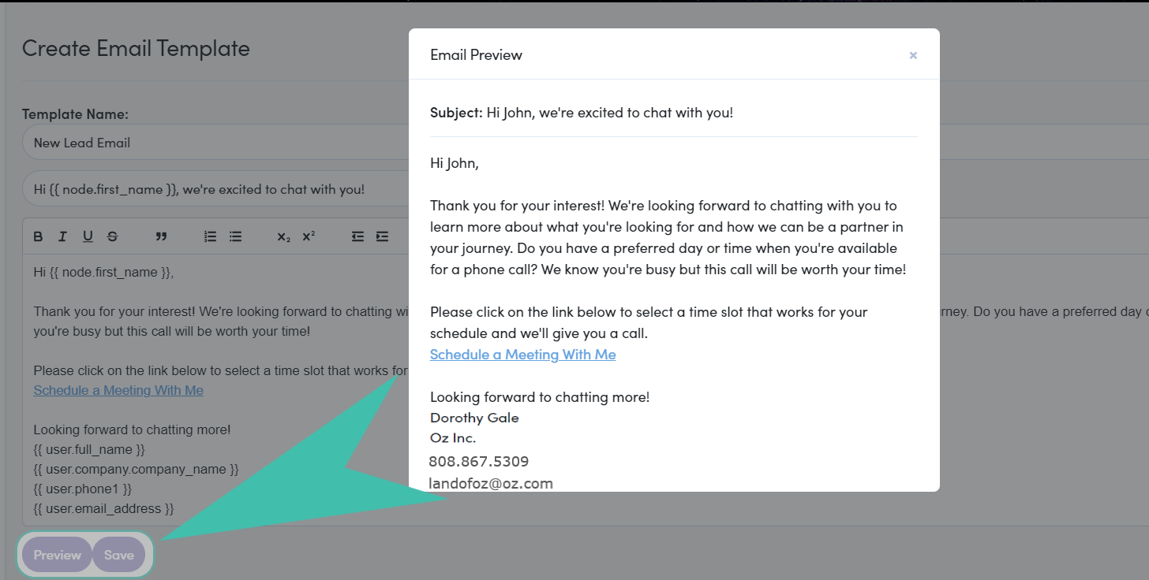

Congrats! Your new email template can now be found from the “Email templates” list.
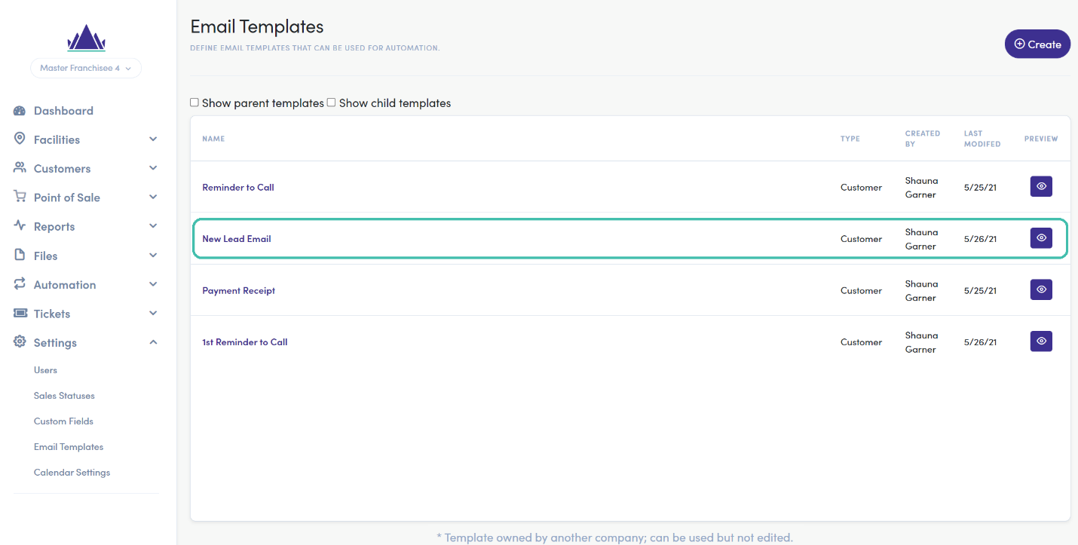

Workflows
Having a template is great, but do you have the resources or time to send the email to each lead manually? Email templates become powerful when you tell FCOS automations what to do with them. Workflows are exactly this: a series of performed actions when a certain event (known as a trigger) occurs, and conditions are met. You can find Workflows under Automation in FranchiCzar OS.
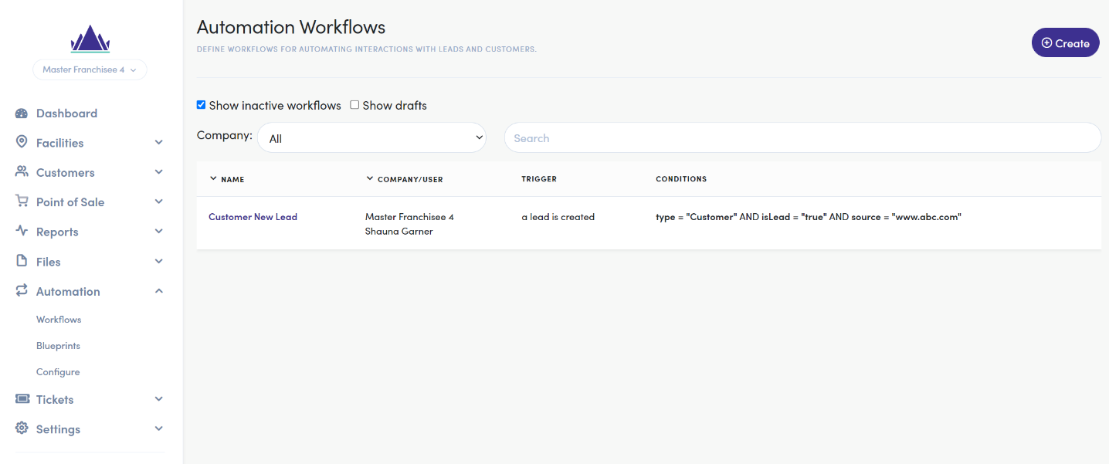

Let’s break down what this page shows:

- Show inactive workflows
  - Displays workflows that are deactivated (default on)
- Show drafts
  - Displays workflows that have not yet been published (default on)
- Company
  - Companies are the franchises or franchisee you are part of. This will default to “All”, but you can show workflows for only a specific franchise or franchisee by selecting one from the drop-down.
- Workflow list
  - Name
    - The name of the workflow
  - Company/User
    - The franchise/franchisee’s workflow and user who created it
  - Trigger
    - What starts the workflow
  - Conditions
    - What criteria must be met to trigger the workflow

Workflows consist of “triggers”, “conditions”, and “actions”. For example, let’s use the Wi-Fi case:

- The trigger is when your phone is within range of a Wi-Fi source.
- The condition is that the Wi-Fi has been previously used.
- The action is to connect to that Wi-Fi network automatically.

All of these occur because the trigger and condition were true. The Wi-Fi wouldn’t connect if you hadn’t connected to it before. The same is true for FCOS – the workflows initiate only when your triggers and conditions are true. Let’s dive a little deeper into what these are.

Triggers
Triggers are events that start a workflow. What do you want to happen to trigger a workflow? FCOS has defined some events for you:

- A lead is created
- A lead or customer is created
- A lead or customer is modified
- An activity is added

FCOS contains more triggers than those listed above but we will only reference those for the purposes of providing details around triggers, and conditions and their impact on a workflow.

Here are some use cases for each trigger:

Trigger | Use case
A lead is created | When someone submits a lead form  When leads are imported from a CSV file
A lead or customer is created | In addition to the above; When someone becomes a customer without becoming a lead (registers at the center)
A lead or customer is modified | When any lead or customer field (name, email, lead status, Interests, Child Name, etc.) is updated or changed
An activity is added | When any inbound or outbound communications occur, including ones  from automations

Conditions
Triggers can be further defined with conditions or criteria about the trigger that must be true. What if you want to trigger a workflow only when the activity is an incoming email? With conditions, this is possible.

Default conditions that come with every trigger are:

Condition | Values | Use Case
Type | = Customer (always true) | None – all leads are Customers
Source | = [any value]  = oz.com (from lead form) | Specify if the lead was organic (oz.com) or from an event, etc
Parent | = [facility/franchisee] | Specify which facility/franchisee the lead is for
Status | = Lead  = Active  = Closed, etc. | Specify the lead’s status. Use with caution as all  new leads’ status is set to the default sales status
Assigned user | = Unassigned  = [user] | Specify who the lead is assigned to
isLead | = true  = false | Specify if the node is a Lead or Active Facility  Customer

Some triggers have special conditions:

Trigger | Special Conditions | Values | Use Case
A lead is created | None
A lead or customer is  created | None
A lead or customer is modified | isLead is changed | = true  = false | Lead becomes a  customer
 | Status is changed | = true  = false | When the sales status is changed
 | Assigned user is changed | = true  = false | When the lead is re-  assigned or becomes unassigned
An activity is added | activityType | = email  = call  = text  = appointment | Specify the type of communications
 | activityDirection | = incoming (from customer)  = outgoing (to customer) | Specify whether communication is  inbound or outbound

Now, let’s build a trigger for the incoming email example:

Trigger
Event | Conditions
When an activity is added | AND | activityType = email
 | AND | activityDirection = incoming (from customer)

These conditions allow the automation to filter through leads with new activity until one satisfies the criteria.

Custom fields can also be used as conditions for a trigger. For example, let’s say we only want the above trigger to activate if the lead is interested in a specific program as well. This is possible by adding another condition for the trigger: Interested in [Example Product] = true. As a result, we would have a trigger that looks like this:

Trigger
Event | Conditions
When an activity is added | AND | activityType = email
 | AND | activityDirection = incoming (from customer)
 | AND | Interested in [Example Product] = true

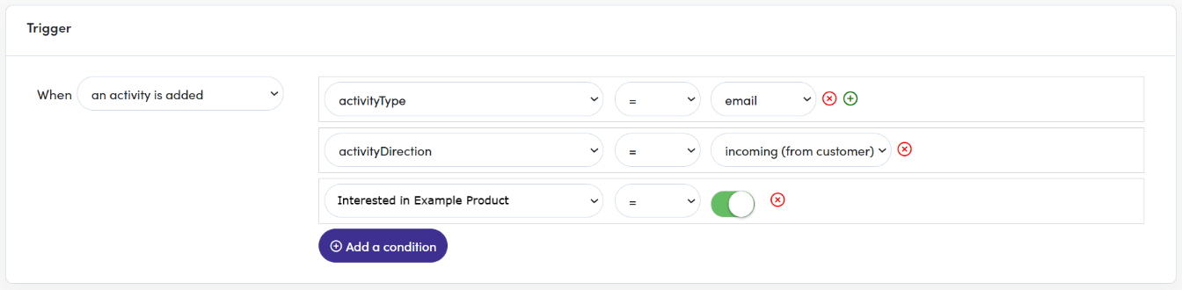
In FranchiCzar OS, you will see something like this:

Actions
Now comes the real question: What do you want the workflow to do for you? Unlike triggers, your workflow can have multiple actions to automate your processes. Actions are communications sent, or changes made to a lead once the trigger conditions are met.

Each action can be immediate or delayed:
- Immediate: Action occurs immediately when the workflow triggers.
- Delayed: Action occurs after a period of time when the workflow triggers. It can be minutes, hours, or days later.

Here are the types of actions available to use in workflows:
- Add a note
- Add a tag
- Assign a user
- Create a new ticket
- Send an email
- Send FCOS notification
- Send a text message
- Send a webhook
- Start an outgoing call
- Update a field

Additionally, each action can be customized to your liking. Let’s look at a few specific actions to see what can be modified.

Send an email
Sending an email is one of the most common workflow actions. You will see something like this when you select this action:

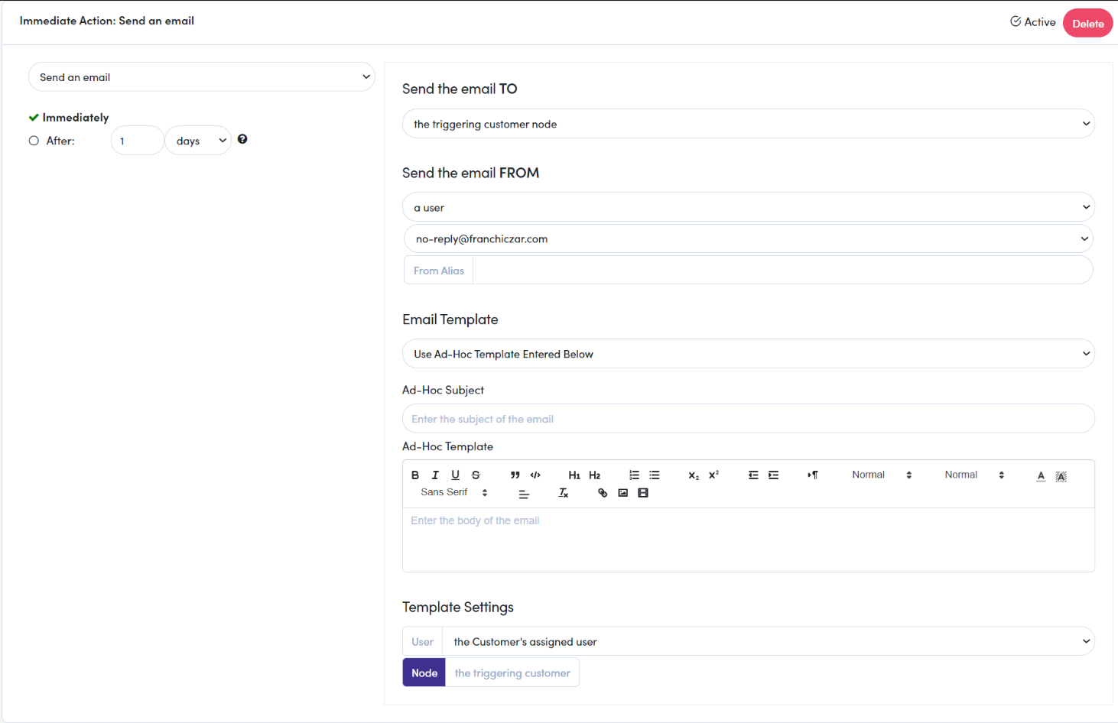

Here is a breakdown of this view:

- Top-left, you can define when the action will occur.

- Top-right, you can adjust who you Send the email TO. Current options include,
  - Node
    - the triggering node node (customer)
    - the triggering node’s parent node (customer’s parent)
    - another node (facility/franchisee)
  - Users
    - a specified user
  - Other
    - an email address
- Right-side, you can also choose (your) Send the email FROM address. Options include,
  - a user
  - the node’s (customer’s) assigned user
  - a shared email address (able to designate an alias email)
- Right-side, we see our Email Templates again! Drop-down displays the email templates created,
  - For this example, we will use the Ad-Hoc email template
  - You can see a preview of the email in the bottom-right corner.


To use email actions in workflows, you must have an email template. The workflow pulls your published email template(s) into this list or allow you to create an Ad-Hoc template.

Last, the template settings will allow you to define the user specified within the template. This will populate the User fields in the email (i.e. {{ user.full_name }}, etc.)

Send a text message
This action has become popular due to the rise of mobile adoption and preference over email. You will see the following options when configuring a text message action:

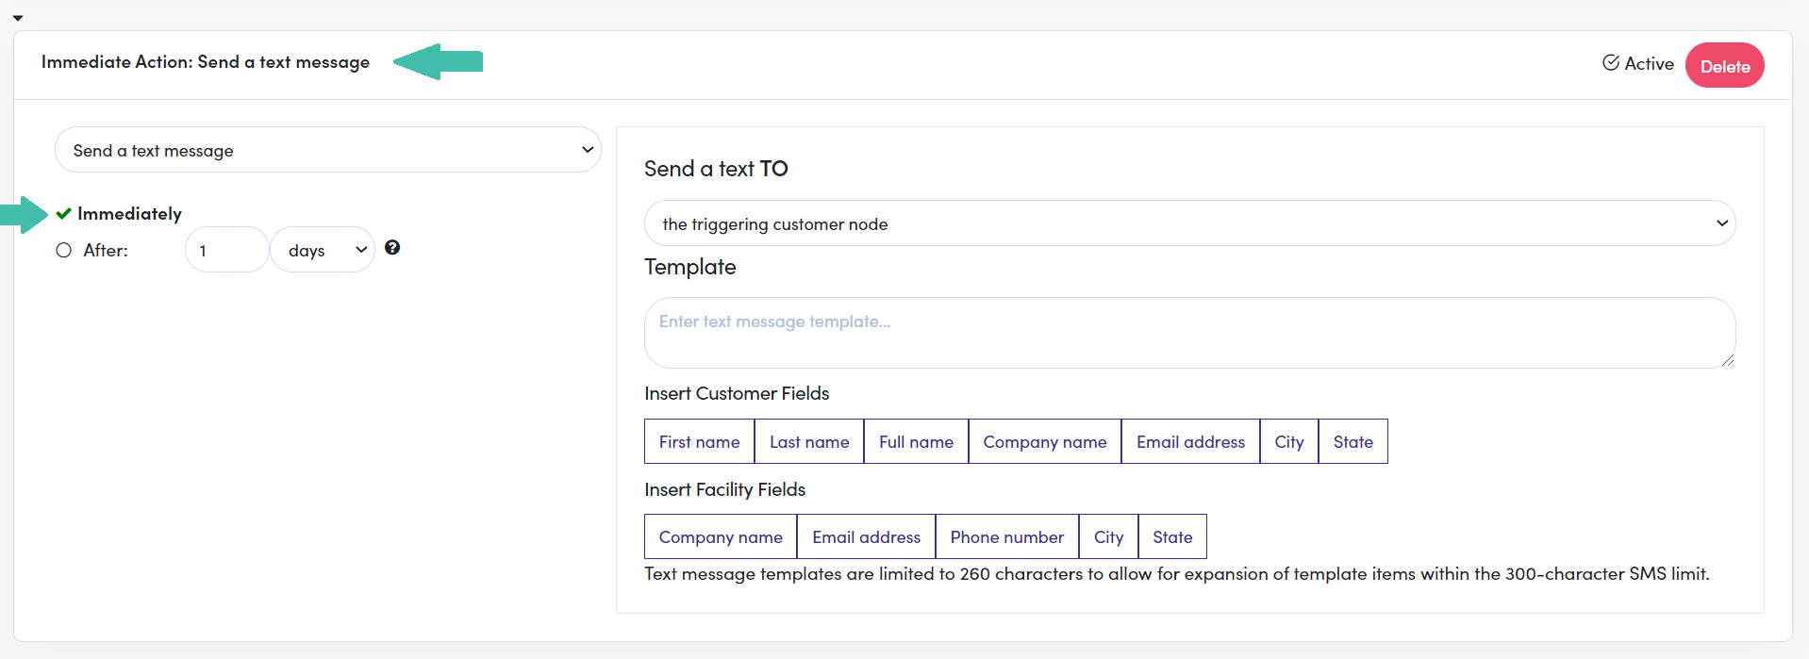

- Top left, like the email action, you can define when to send the text.
- You also have the same recipient options as an email for Send a text TO,
  - Node
    - the triggering node node (customer)
    - the triggering node’s parent node (customer’s parent)
    - another node (facility/franchisee)
  - Users
    - a specified user
  - Other
    - a phone number
- The major difference is you must type the text message in the Template field.


Currently, text message templates are not a feature, but may be released in a future update. Please note, in the above example your text will be sent immediately; however, below (image/example) it is delayed.
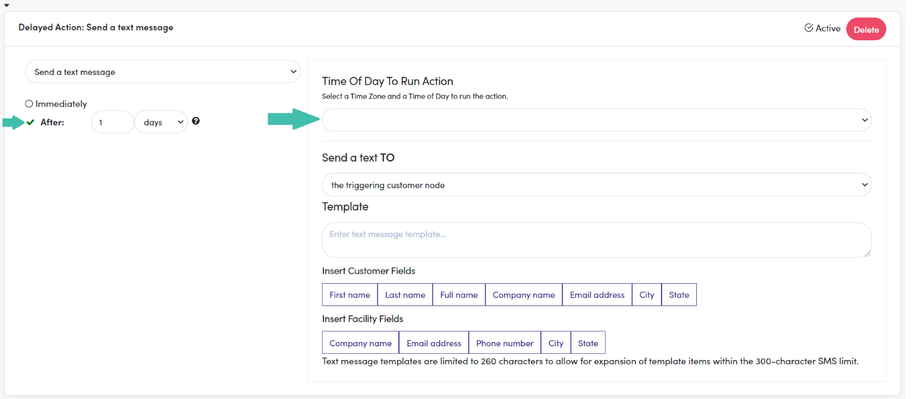

In the above image, you will need to set the time of day. Once you select the time zone, a counter for hours, minutes and A.M. vs P.M will appear and need to be defined. The counters will not surface until the time zone is define. Compare the two images (above – undefined time zone; below - defined time zone).
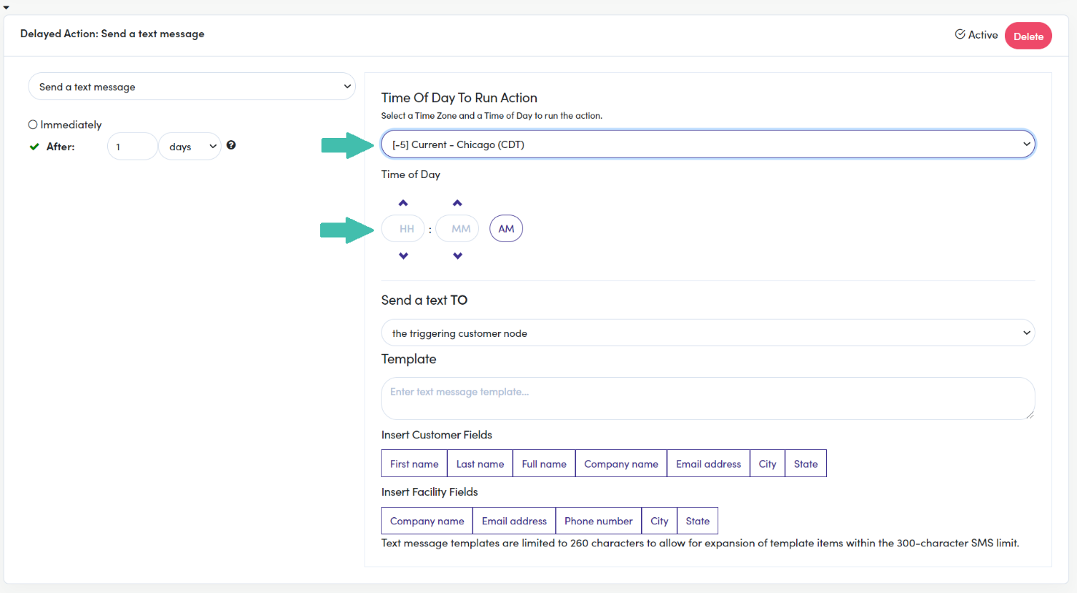

You can also choose to send the text at the same time as the triggered time, which will send the text as soon as the trigger occurs. If this option is selected you will not need (nor be able) to define the hours, minutes, A.M or P.M. of when the outgoing text will occur.

The syntax is the same for both your email and text message templates. For example, {{ node.first_name }} in the text will be replaced with the customer’s first name. Node fields are discussed earlier in the guide if you need reference to what these are. We also have resources available within the FCOS file repository for further templating documentation.

Update a field
This action helps you categorize your leads and ensure they are the most up to date when looked at. You will see the following options when selecting this action:
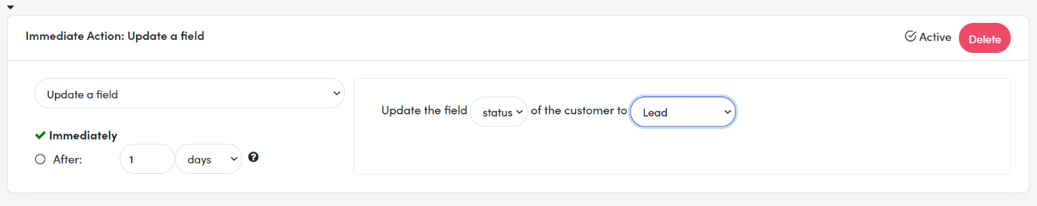

After setting any delay, you specify which field should be updated. Currently, you can choose from “status” and any custom field. Then set the value you want the field to change to.

Assign the lead to a user
In addition to adding any delay, you can assign a lead node to a specific user or users:
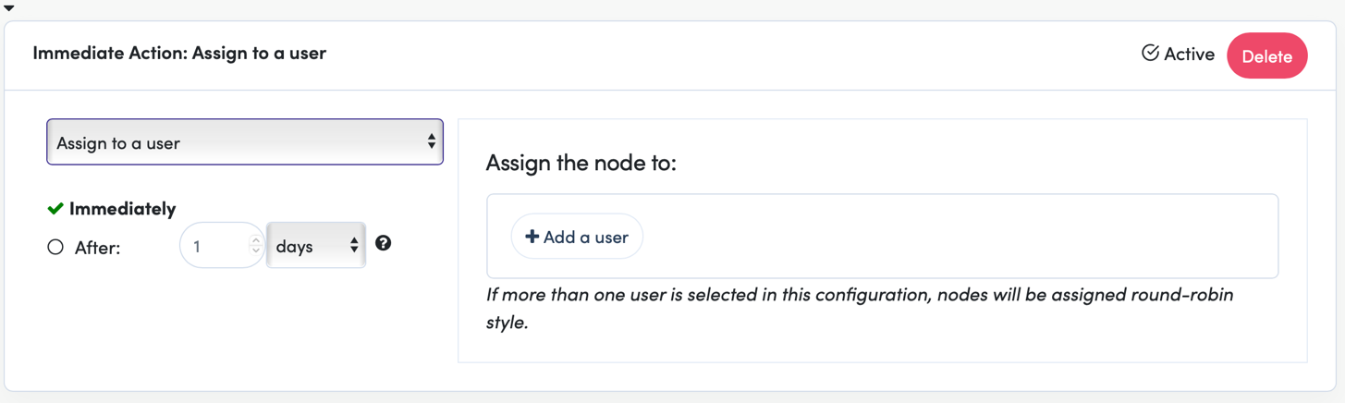

If you add more than one user for this action, the leads will be assigned round-robin style. This means the first lead will be assigned to the first user, the second lead to the second user, and so forth

Creating a Workflow
Now that you know what workflows consist of, let’s put them into practice. We will use a couple examples to showcase the power of automations.

Example 1: The New Lead
- Emailing new website leads immediately encouraging them to book a tour.
- Assign the leads to the center director.
- Text the lead after 5 minutes telling them to check their email for a special offer.
- Update the lead’s status to indicate a welcome email was sent.

Step 1: Name Workflow
Whew—that’s quite a bit of work we want our automation to do. But no worries; automations are built to perform multiple actions for one trigger. Let’s start by giving the workflow a name.
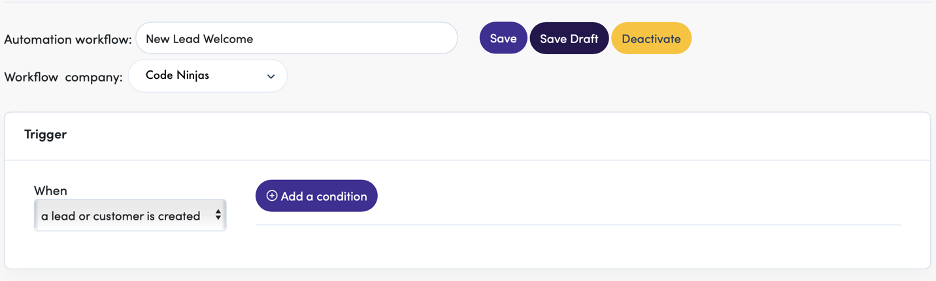

“New Lead Welcome” indicates the general goal of the workflow. Next, we’ll configure the trigger.

Step 2: Add Trigger
Since we only want leads from the website, we will add a condition that source = codeninjas.com
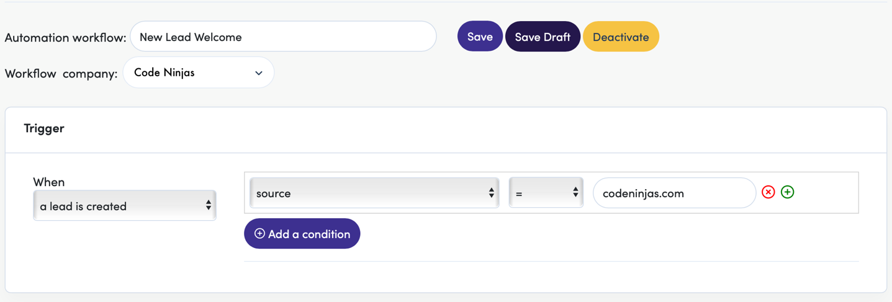


That’s all we’ll need to configure for the trigger. The other conditions (type, parent, status, or assigned user) are not important for this workflow to trigger.

Step 3: Action, Send Email
Next, click 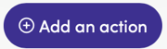 to begin (you guessed it) adding actions! Let’s start with the first item: Email new website leads immediately encouraging them to book a tour.

We already created an email template called “Code Ninjas Visit” encouraging leads to visit the center. We will use this in this action. As stated earlier, you MUST have an email template created to use the email action.
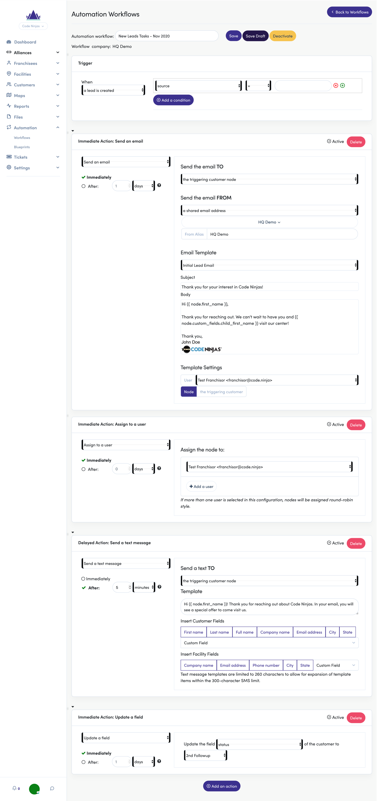

We did not turn on a delay. The email will be sent to the triggering node (the lead/parent) from one of our shared mailboxes, HQ Demo. For you, the shared mailbox may appear in the format of [City, State]. We customized our “from” name and indicated the template we’ll be using.

Additionally, we set the template user to be “Test Franchisor” for all these automated emails. This test info populates into all {{ user }} fields, such as the email signature.


Emailing may fail if you leave the template user as “the assigned user” and there is no user assigned.

Step 3: Action, Assign User
With the email done, we can move on to assigning the lead to the center director. Click  and select Assign the lead to a user.
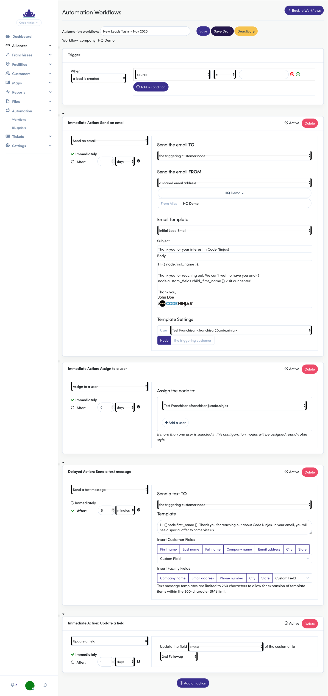

We set this action to assign the lead immediately to the Test Franchisor.

Step 4: Action, Send Text
Next, we want to text the lead after 5 minutes telling them to check their email for a special offer. Click 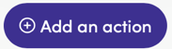 and select Send a text message, as the action.

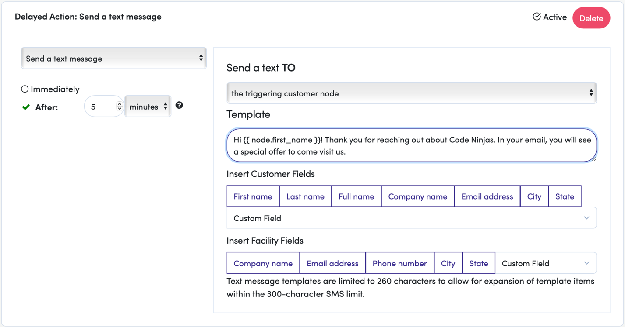

We set a 5-minute delay which is indicated in the blue banner above. We chose to send the text to the parent and typed a short reminder message about the email.


As you can see, we used the same email template syntax to reference the lead’s first name, {{ node.first_name }}.

Step 5: Action, Update Field
Last, we want to update the lead’s status to indicate a welcome email was sent. The Update a field action can help us do this.
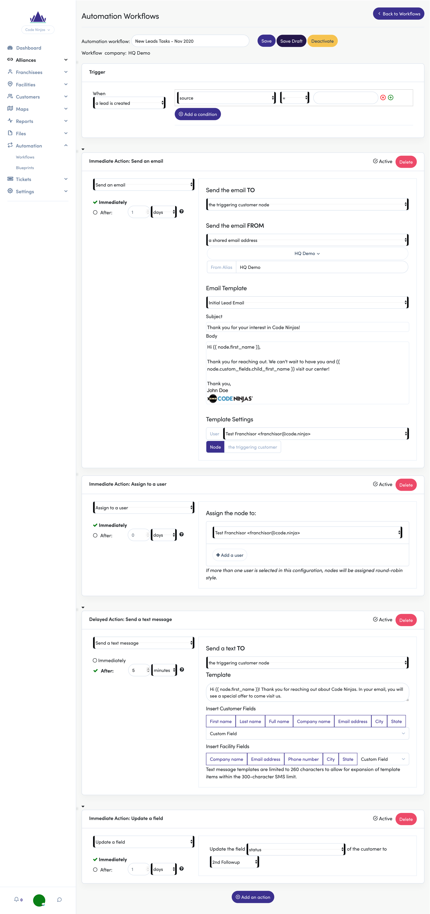

We set the status to immediately update to 2nd Followup. This will help us decide which leads need to be reached out to again.

Step 6: Save
After you’ve reviewed all your “Actions” and “Triggers”, click Save or Save Draft.


Saving it will publish the workflow and begin immediately. Saving it as a draft will keep your changes but remain idle until you publish it.


Please see below for the “Completed Workflow” and to compare with what you have.

Example 1: Completed Workflow
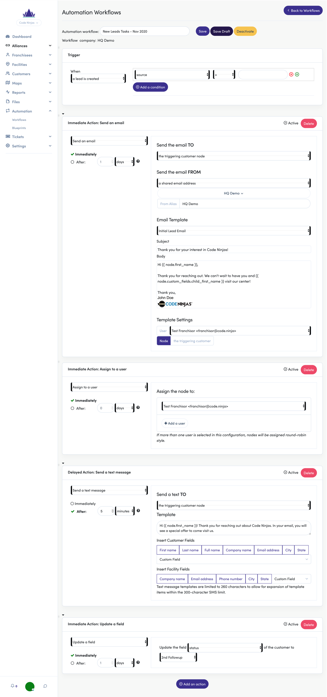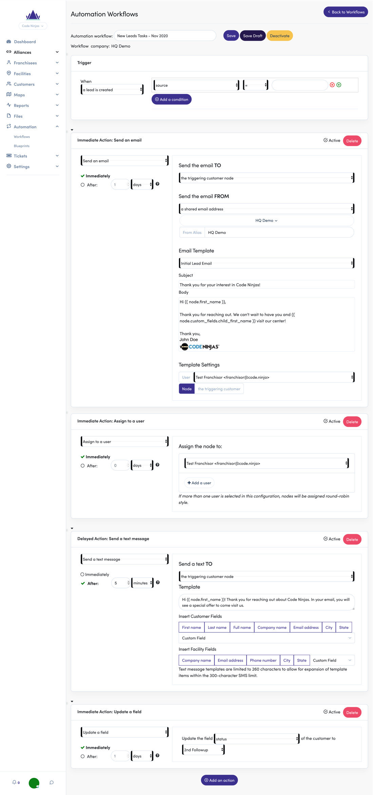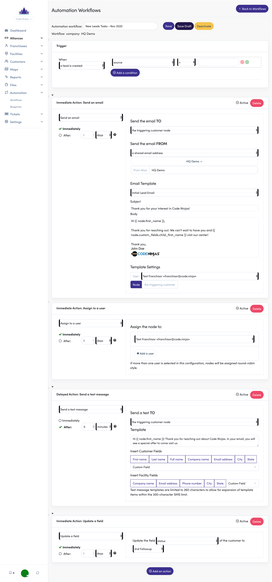
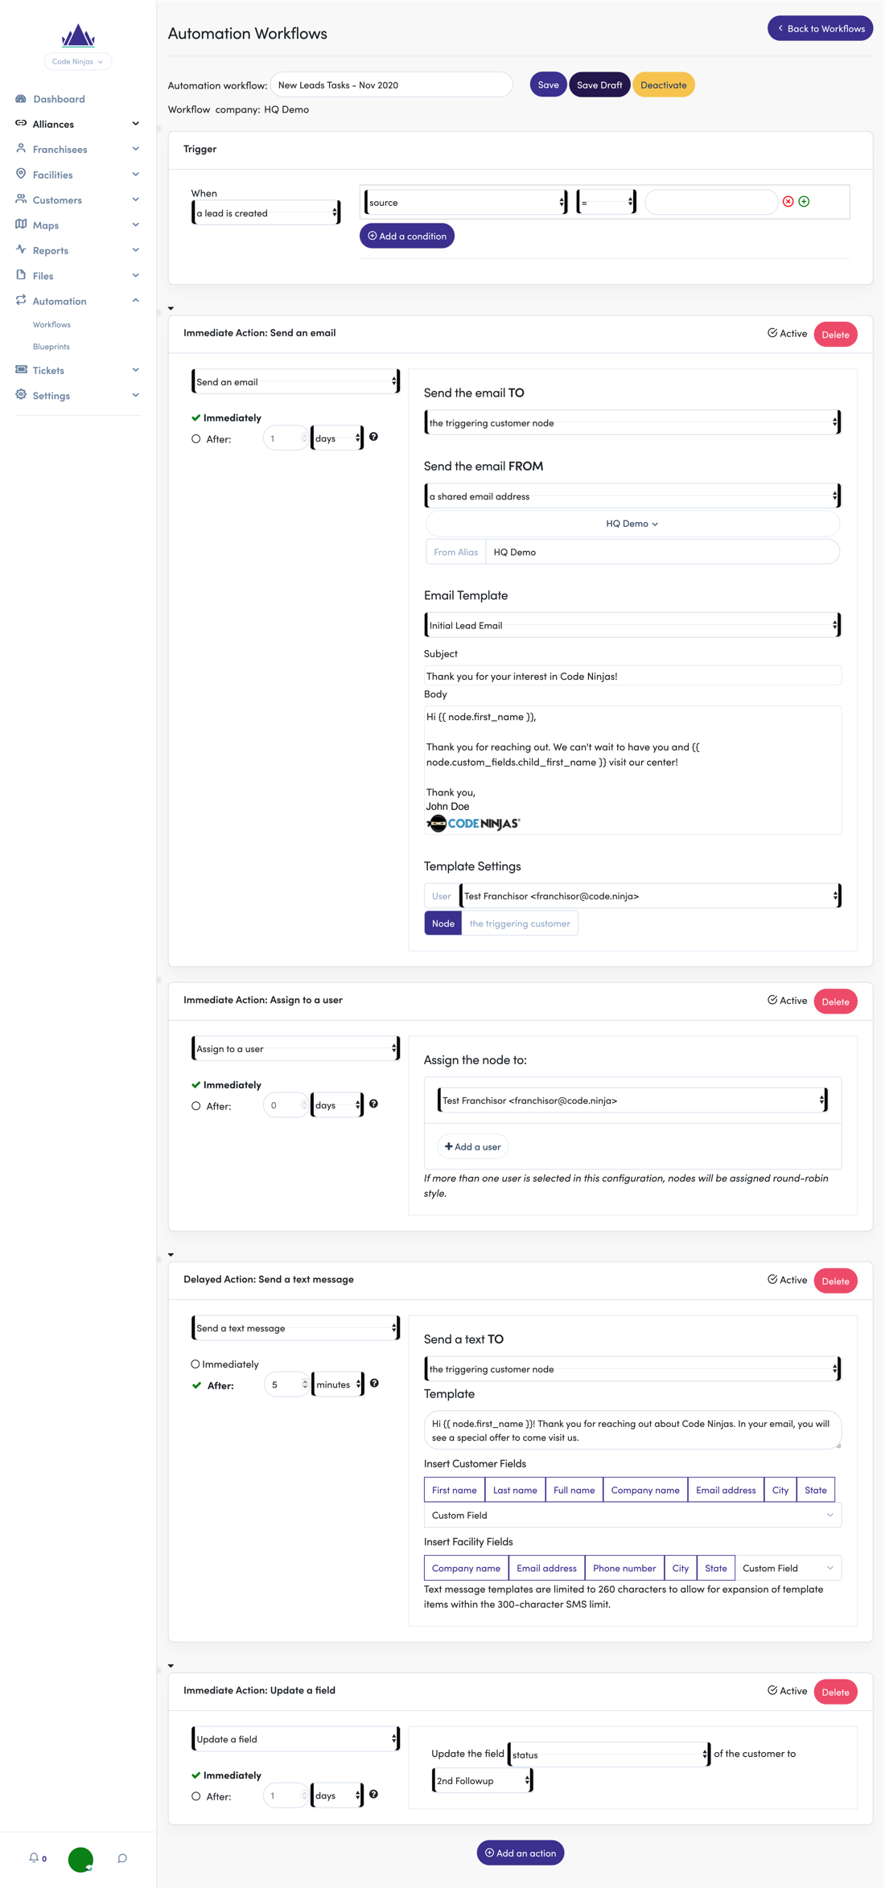
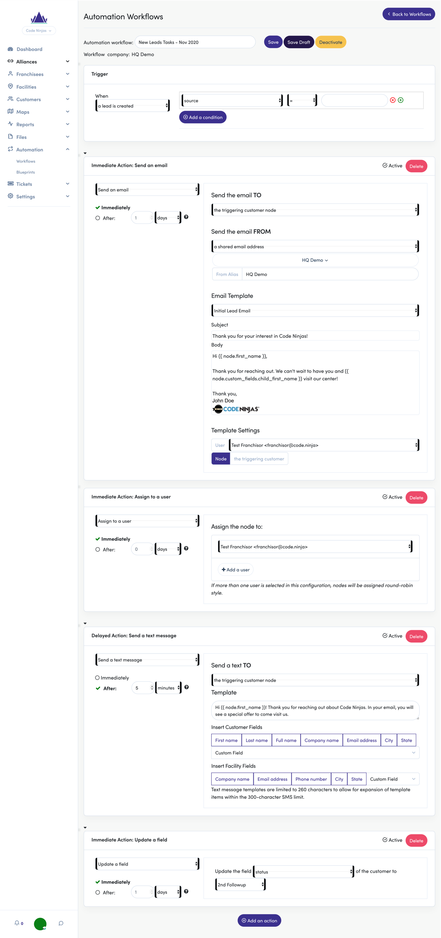

Example 2: Purchase Order Receipt
- Send an email (receipt) to a Customer following a purchase

Handling purchases is the bread and butter of your business. Your PoS system manages transactions and transaction history but setting up an Automation to send your customer a digital receipt.

Step 1: Name/Add Trigger
First, we’ll give the workflow an applicable name and set its Trigger. Since this isn’t a new lead, how can we let FranchiCzar OS know they completed a tour? The sales status is usually the best way to indicate this. You can also use custom fields (i.e. Tour Complete = true/false) to achieve the same result. Here is what the trigger will look like:
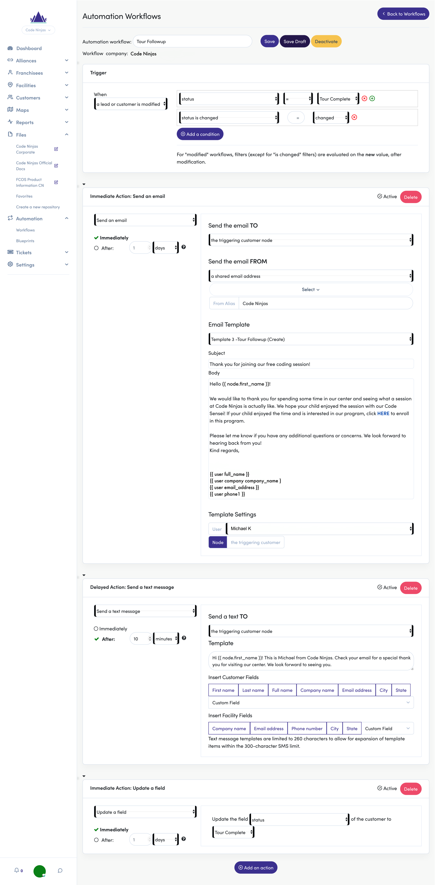

What are we telling the workflow to look for? There are two conditions: the status is changed, and the status = ‘Tour Complete.’ You can read this as “the status is changed to Tour Complete.” The order of conditions does not matter. FranchiCzar OS will not check the status first, then if it was changed. It will check for the conditions simultaneously.

Step 2: Action, Send Email
Now that we have the trigger configured, let’s set up the first action; “Send an email” thanking the parent and offer to discuss program options.

To begin, click  and select Send an email from the drop-down menu.


We chose the email action with no delay (Immediately).

We created an email template called “Tour Followup” for this. The TO field is defaulted to “the triggering customer node” (which is correct); ensure you have made your selection within the FROM drop-down. Then we configured the settings to have our director (this is specific to your preference), Michael, be the email composer (used in the signature):
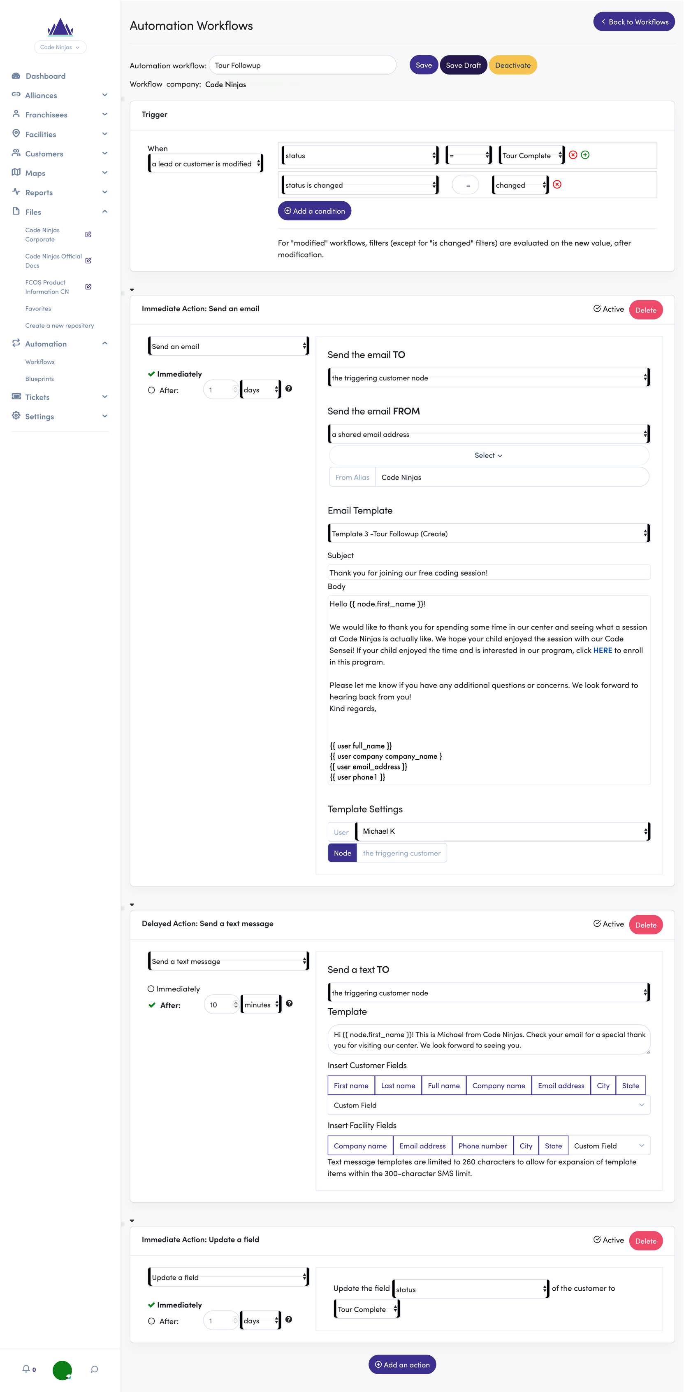


Remember, you MUST have an email template created to use the email action.

Step 3: Action, Send Text
Our next action will involve a text message: Send a text thanking the parent and to check their email for an offer.

Begin by clicking  and selecting Send a text message from the drop-down menu. We will set a 10-minute delay on this, so the email has time to arrive in the parent’s inbox before receiving the text.
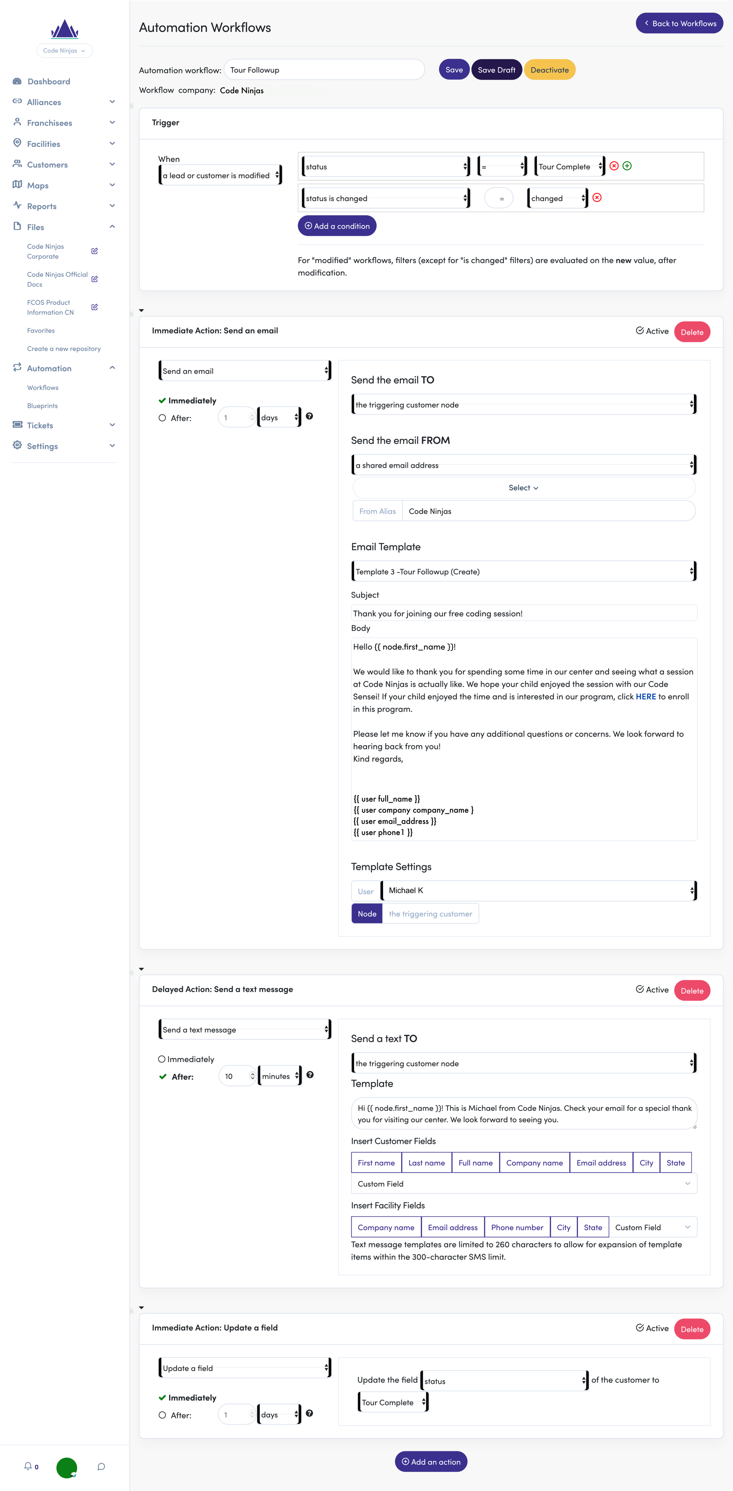


As you can see, we used the same email template syntax to reference the lead’s first name, {{ node.first_name }}.

Step 4: Action, Update Field
Last, we want to update the status, so we know our next steps for the lead. Click  and select the Update a field action to help us do this.
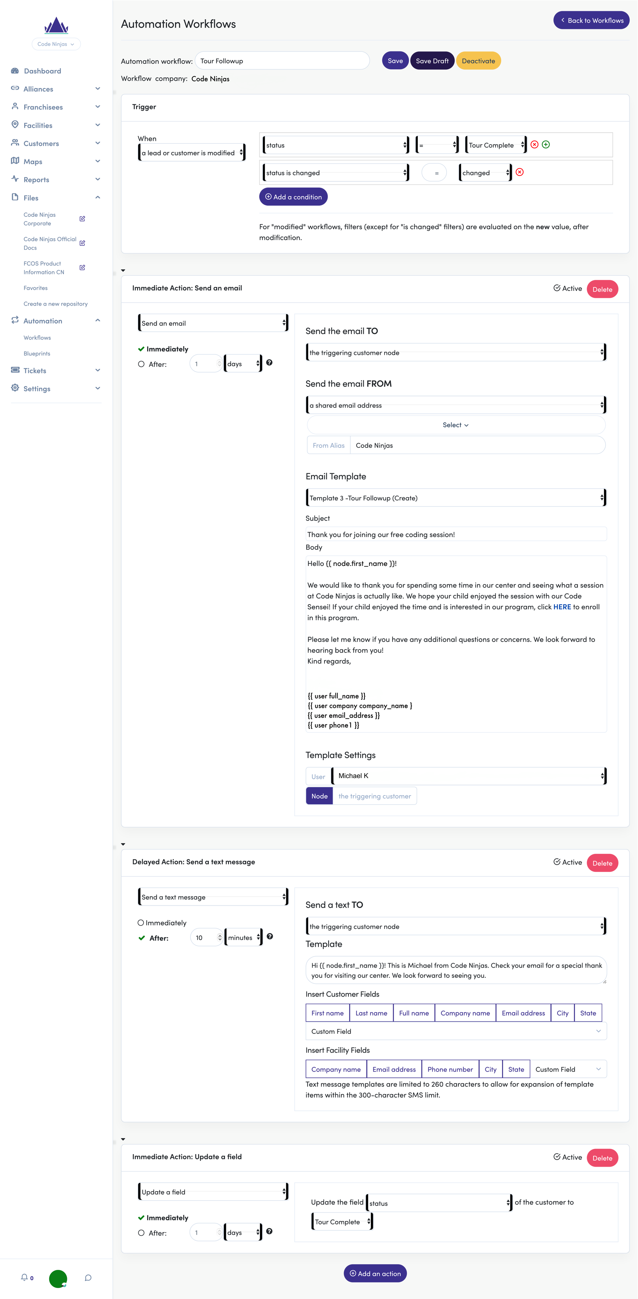

We now know where this lead is at in the conversion process by updating the status field automatically to call after Tour [is] Complete.

BOOM! Now you’ve just built a front-to-back automation for following up to leads after tours (see the completed automation below).

Step 5: Save
After you’ve reviewed all your “Actions” and “Triggers”, click Save or Save Draft.


Saving it will publish the workflow and begin immediately. Saving it as a draft will keep your changes but remain idle until you publish it.


Please see below for the “Completed Workflow” and to compare with what you have.

Example 2: The Tour Followup (Complete)
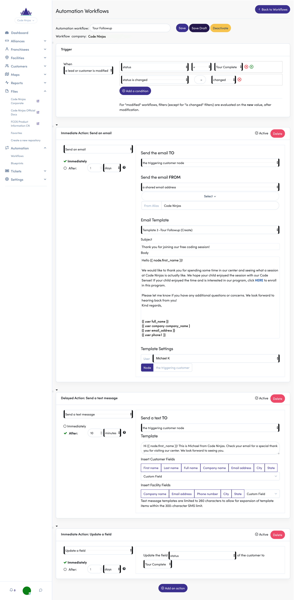

Blueprints
What if you could use proven automations right out of the box? That’s what Blueprints are: Sets of workflows with subsets of actions that you can ‘opt-in’ to use.

Code Ninjas HQ is currently developing blueprints based on lead conversion successes with current workflows. These will be available in the coming months.

This section will be updated when Blueprints are ready for franchisees to use.



Frequently Asked Questions (FAQs)

Why are email templates under "Settings" and not "Automation”?
Email templates are not solely reserved for automations. If you want to use a templated email, you can at any time by visiting a lead page and manually use one there.
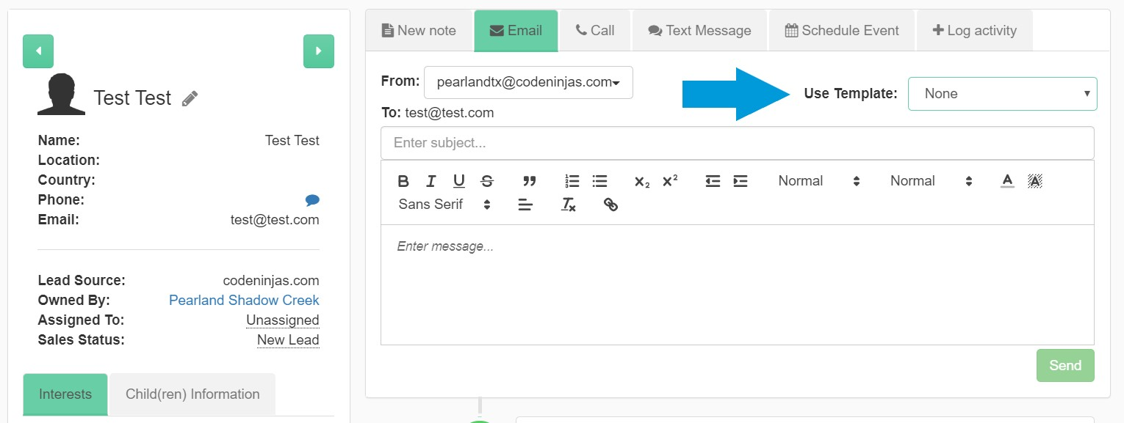

What if I use a template and have set the user as “the assigned user” but no user is assigned?
There is a possibility the email may fail since the template doesn’t have a user to populate those fields. Therefore, it is better to assign the lead to a user first then use any templated emails in automations.

I have multiple conditions for trigger. How does FranchiCzar OS know what to check first?
FranchiCzar OS does not check for conditions in sequence. All conditions are checked simultaneously. Therefore, it is best to only add conditions that would be true at the same time. Otherwise, the trigger may never start.

My automations aren’t working for new leads. What’s happening?
As stated above, you want to make sure your conditions are ‘true’ when a new lead comes in. A bad example would be using a custom field (e.g. Child Age) condition for when leads are created.
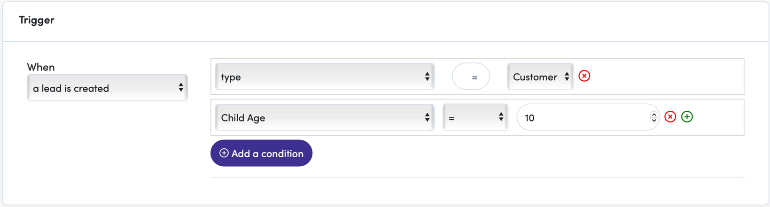

A workflow would never run with the trigger above. This is because “Child Age” is not inputted when a lead is created. It is updated after collecting that information via a phone call or email.

What is a “parent” and why do I see it so much in automations?
FranchiCzar OS consists of a “family tree” of nodes. Here is a breakdown of how parent and child nodes are connected.
 | Node |  |  | Example
Parent → | Broker |  | = | FranchiCzar OS, LLC |  | Child →
 | Franchisor |  | = | Code Ninjas, LLC
 | Franchisee |  | = | Coders, LLC
 | Facility |  | = | Houston, TX
 | User (employee) | Customer (lead) | = | Michael K. (employee) | John Doe (lead)

Appendix A

Version History Table
Date | Version | Description | Owner | Approver
01/19/2021 | 1.0 | Initial version | Shauna Garner
07/19/2021 | 1.1 | Reviewed and updated document screenshots and verbiage | John Beatty
07/26/2021 | 1.2 | Update “Email Template” image | John Beatty

